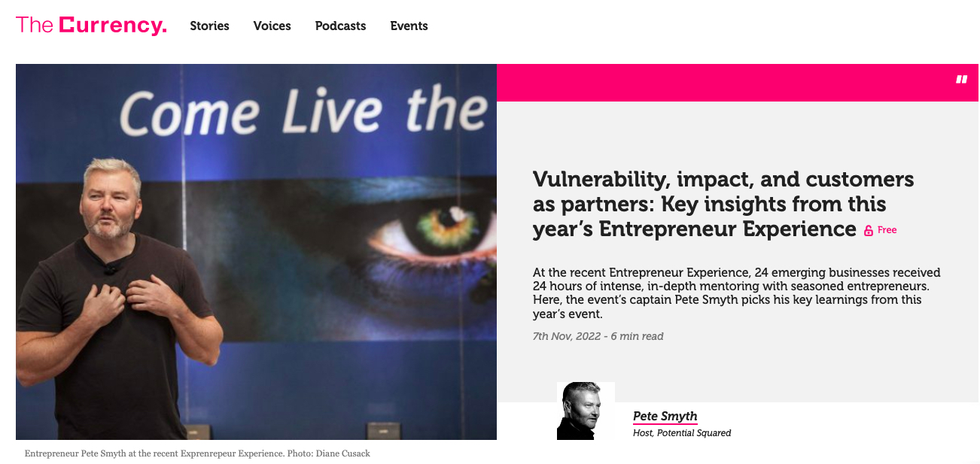
7th November 2022 - At the recent Entrepreneur Experience, 24 emerging businesses received 24 hours of intense, in-depth mentoring with seasoned entrepreneurs. Here the Entrepreneur Experience's captain Pete Smyth picks his key learnings from this year’s event:

Link to the Article: https://thecurrency.news/articles/100663/vulnerability-impact-and-customers-as-partners-key-insights-from-this-years-entrepreneur-experience/

